**Part B:**

Avg Training Error and Test error:

For Monk1

Avg Training error: 0.07258064516129031

Avg Test error: 0.075

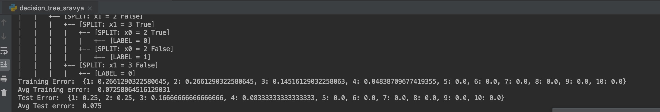

For Monk2

Avg Training error: 0.16863905325443787

Avg Test error: 0.24398148148148152

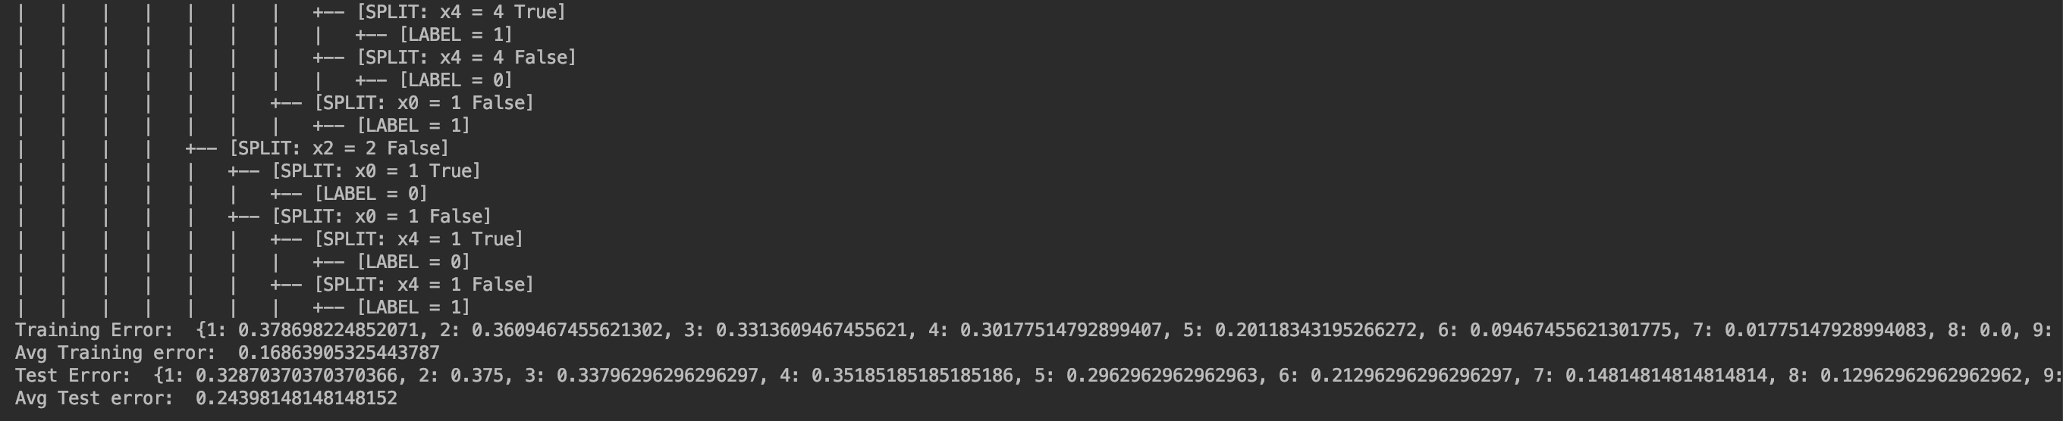

For Monk3

Avg Training error: 0.046721311475409845

Avg Test error: 0.09305555555555556

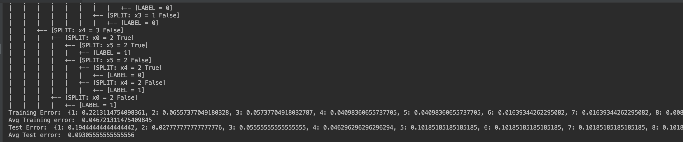

Monk 1

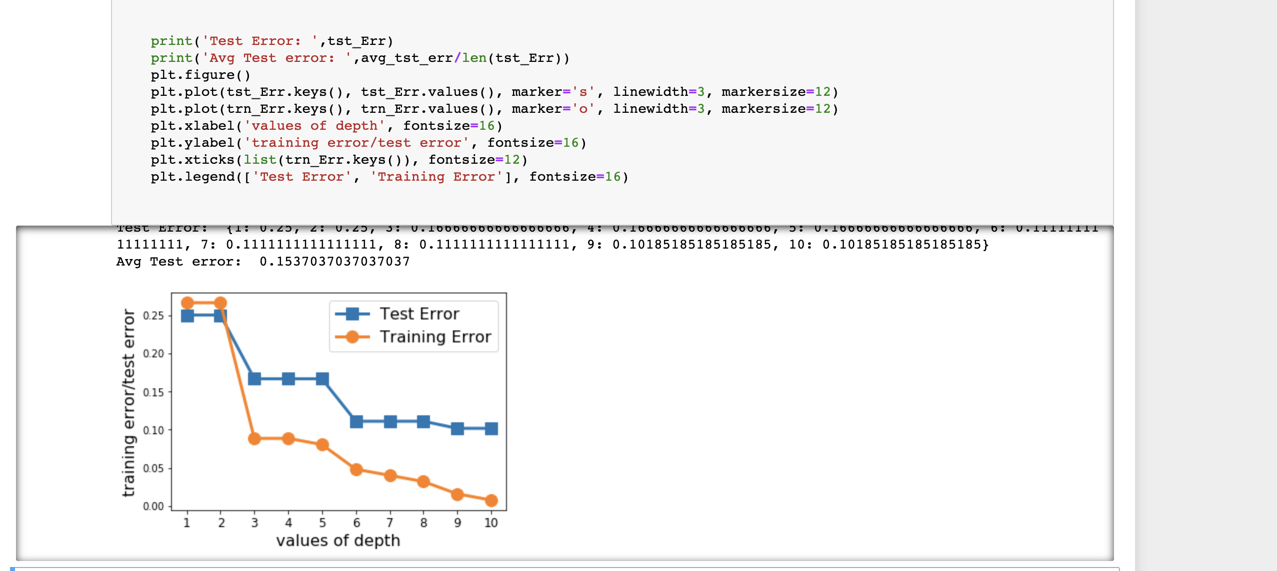

Monk 2

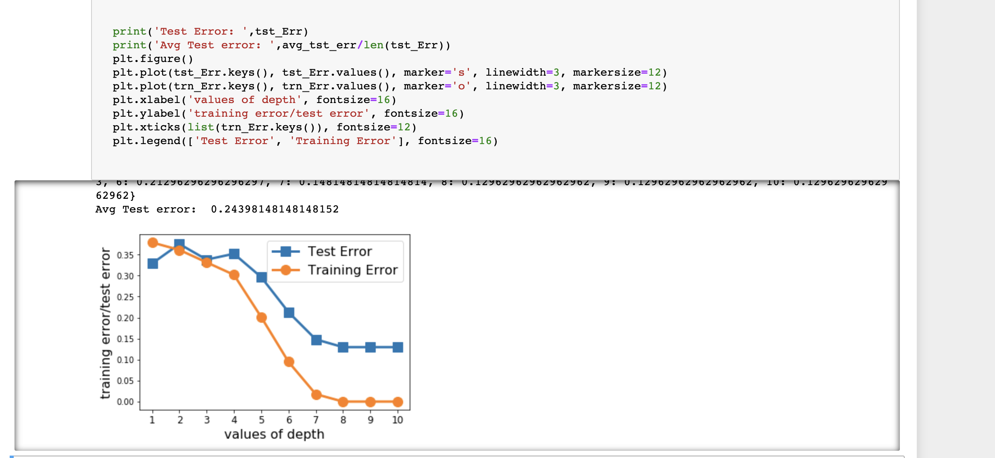

Monk 3

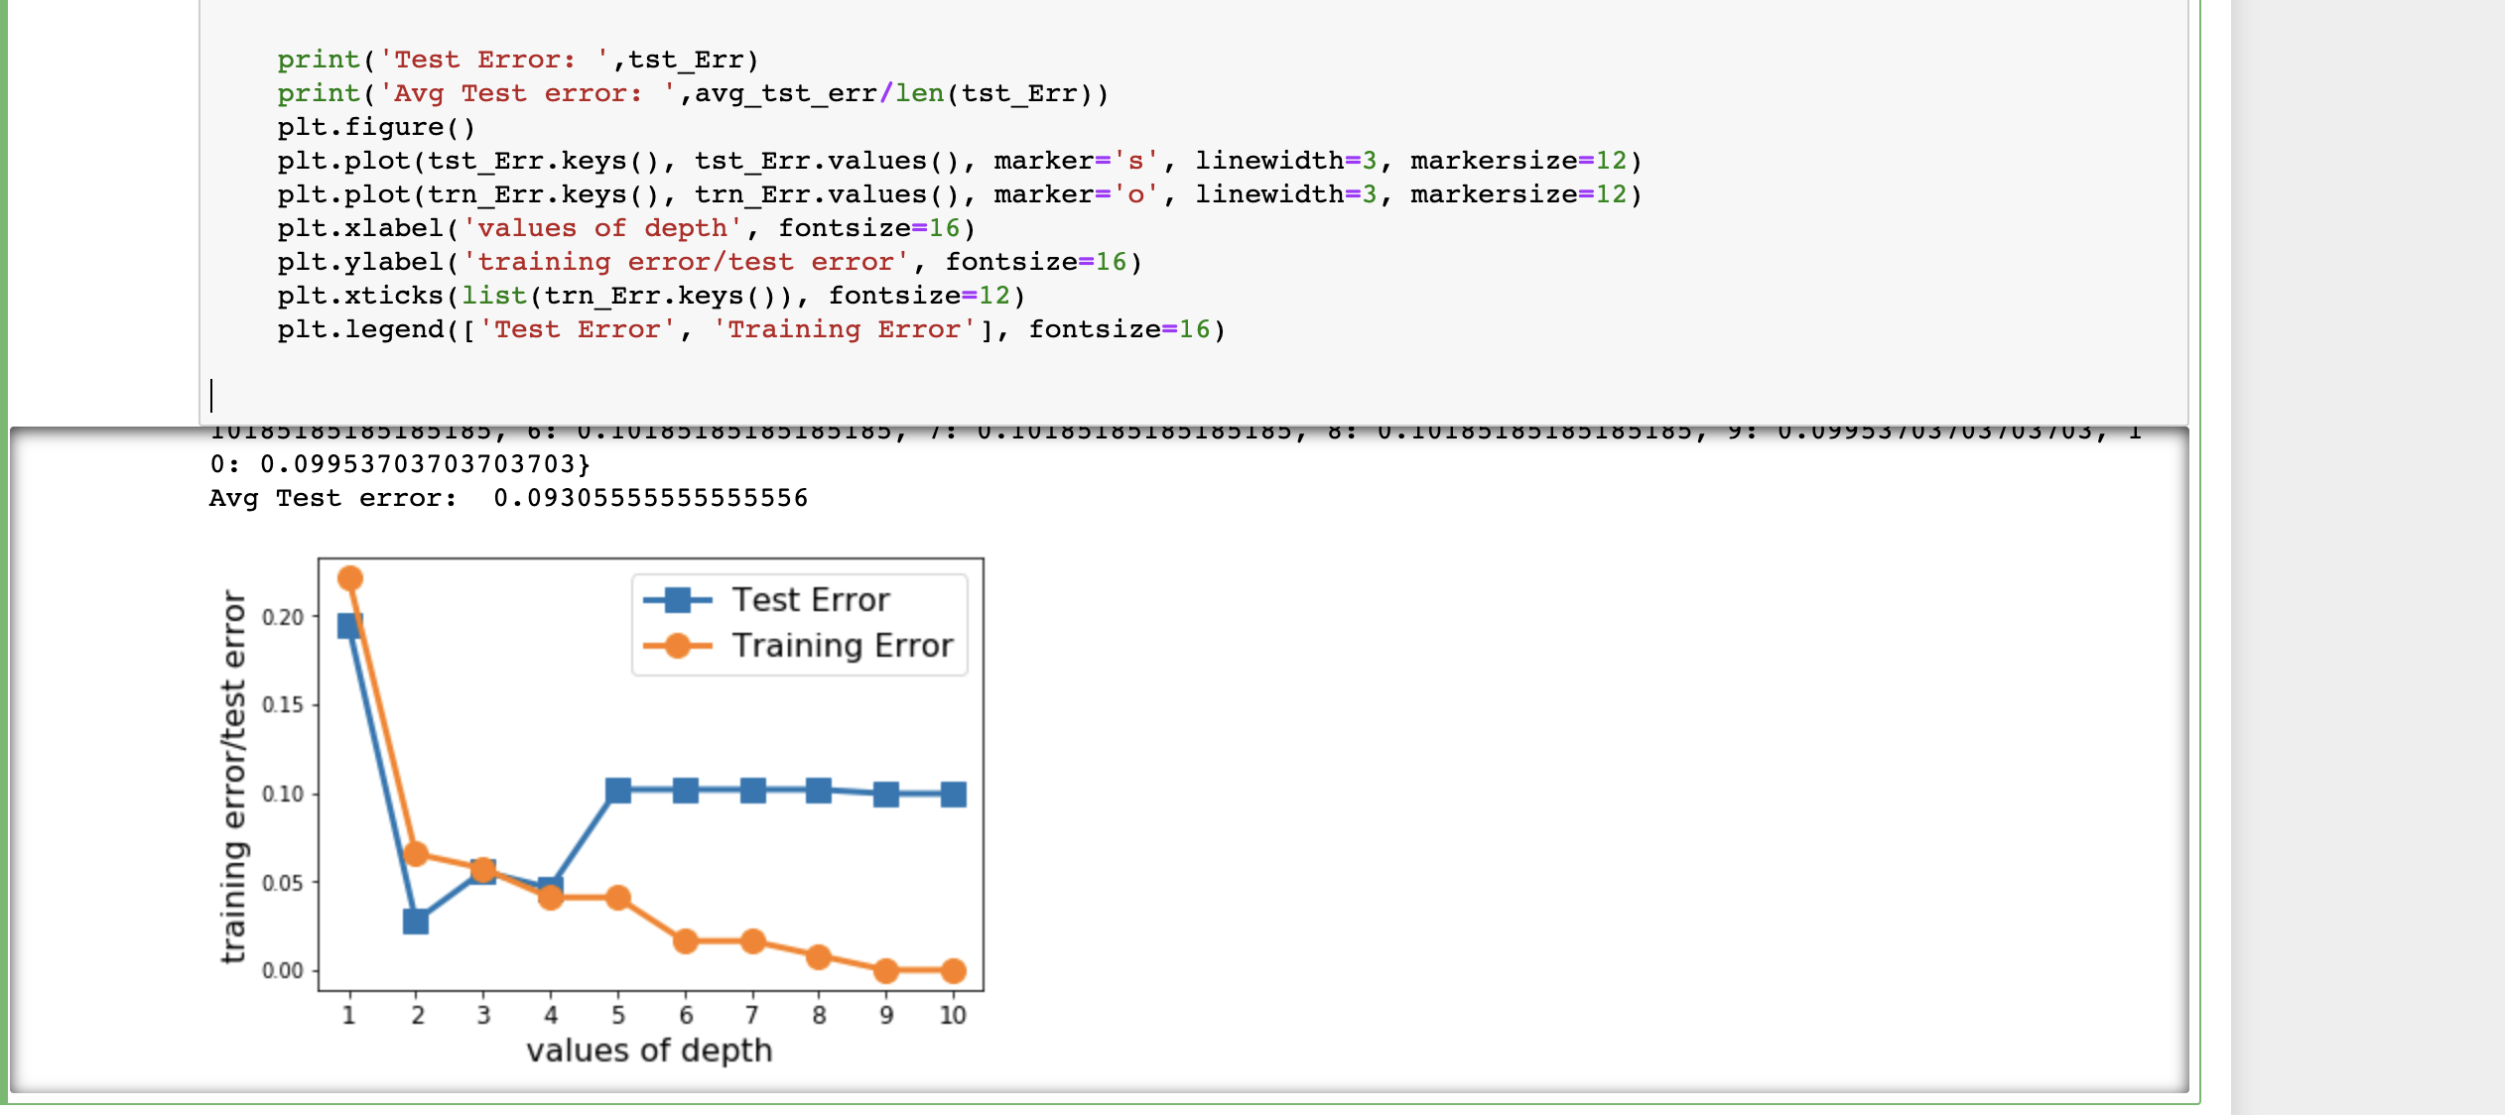

**Part C:**

Monk1

**Depth=1**



**Confusion Matrix:**

[[216 0]

[108 108]]

**Depth=3**



**Confusion Matrix:**

[[144 72]

[ 0 216]]

**Depth=5**



**Confusion Matrix:**

[[156 60]

[ 12 204]]

Part D: Decision tree using scikit-learn (Monk1)

Depth=1



Confusion Matrix:

[[216 0]

[108 108]]

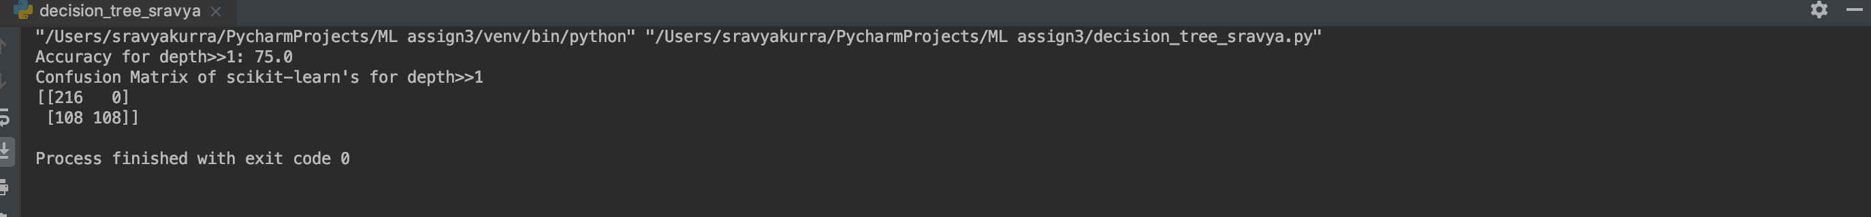

Depth=3



Confusion Matrix of scikit-learn's for depth>>3

[[144 72]

[ 0 216]]

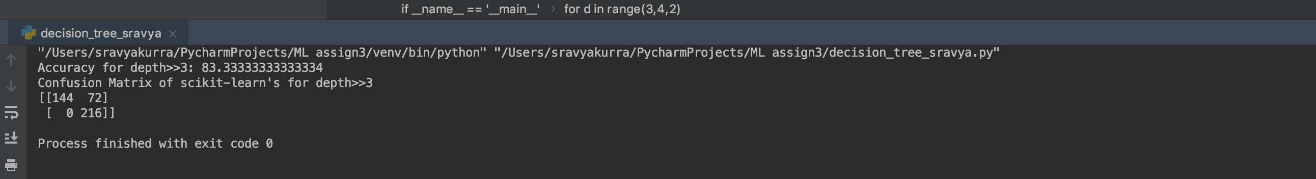

Depth=5



Confusion Matrix of scikit-learn's for depth>>5

[[168 48]

[ 24 192]]

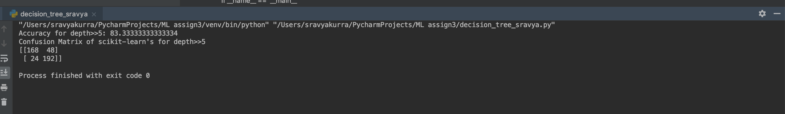

Part E:

**Poker Hand**

ID3 Implementation

**Depth=1**



Confusion Matrix:

[[ 0 0 58651 191286]

[ 0 0 63556 185842]

[ 0 0 63902 186998]

[ 0 0 64253 185512]]



SK Learn implementation



Confusion Matrix of scikit-learn's for depth>>1

[[ 0 127199 122738 0]

[ 0 126827 122571 0]

[ 0 123409 127491 0]

[ 0 122504 127261 0]]

Accuracy: 25.43%

Depth=3



[[ 48536 27357 174044 0]

[ 46868 32248 170282 0]

[ 43256 32335 175309 0]

[ 47051 32373 169851 490]]

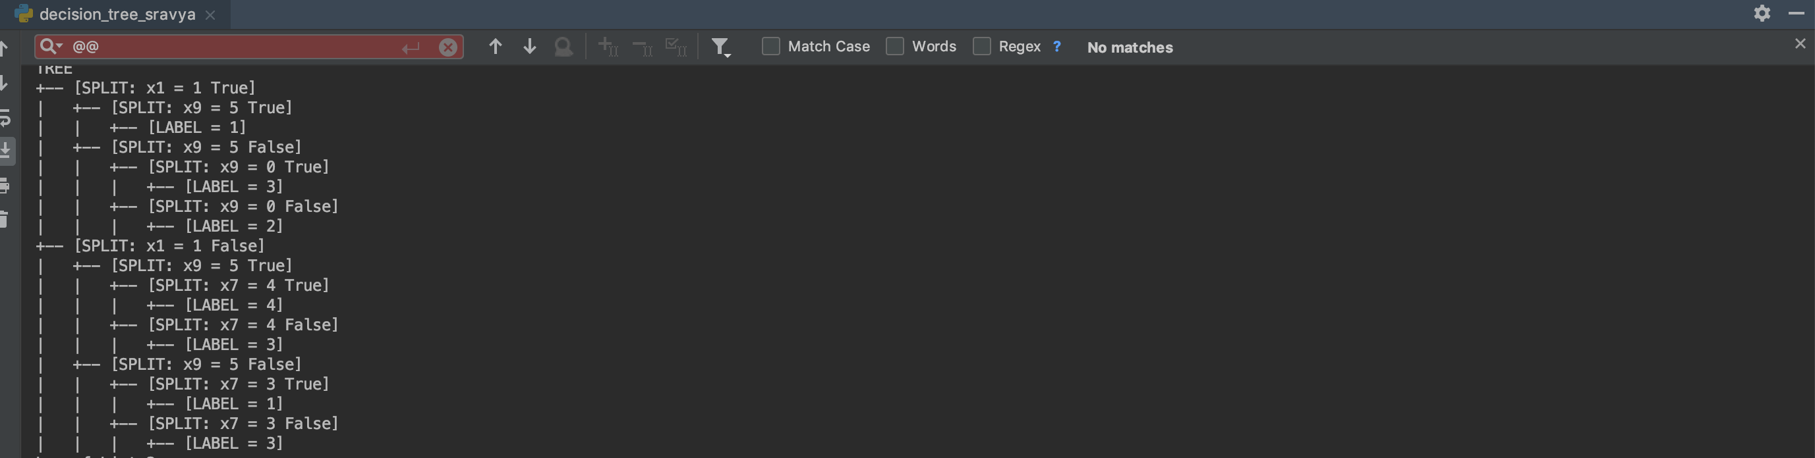

**Depth=3:**



Confusion Matrix of scikit-learn's for depth>>3

[[ 490 63697 75231 110519]

[ 46 63196 76052 110104]

[ 56 58721 80941 111182]

[ 65 57969 80616 111115]]

Accuracy: 25.57

**Depth=5**



Confusion Matrix:

[[ 11698 58559 46518 133162]

[ 10889 64528 46170 127811]

[ 10783 62957 49471 127689]

[ 11111 60522 45913 132219]]

SK Learn:

Depth 5:

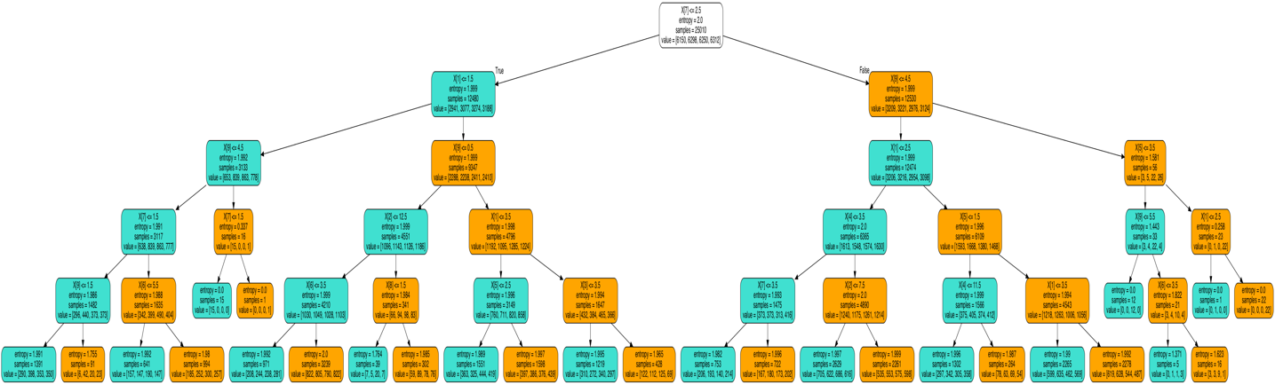

Confusion Matrix of scikit-learn's for depth>>5

[[62752 63967 46140 77078]

[62252 65082 45535 76529]

[62757 61652 50402 76089]

[62233 61081 48654 77797]]

Discussion:

As per results, Our ID3 implementation was almost as accurate as SKLearn’s. Truly speaking it’s little more accurate(like in 0.2-0.4%) than SKLearn.

The Other difference that I found was, Our ID3 chooses left side when split value is equal else it goes to right side

In SK Learn, <= goes left whereas the > goes right